

**A**

**PROJECT REPORT**

**ON**

**“ONLINE NEWSPAPER SYSTEM”**

**AT**

**“NEWS 24”**

**SUBMITED**

**TO**

**SAVITRIBAI PHULE PUNE UNIVERSITY, PUNE**

**FOR THE AWARD OF**

**MASTER OF COMPUTER APPLICATION**

**(MCA-1st Year, SEM.-II)**

**BY**

**SANDESH JITENDRA DHANDE (21252)**

**UNDER THE GUIDENCE OF**

**DR. ASHWINI BRAHME**

**THE DIRECTORSINHGAD INSTITUTE OF MANAGEMENT AND COMPUTER APPLICATION (SIMCA),NARHE, PUNE (AY. 2021-2022)**

|  |  |  |  |  |
| --- | --- | --- | --- | --- |
|  | **SINHGAD TECHNICAL EDUCATION SOCIETY’S**  **SINHGAD INSTITUTE OF**  **MANAGEMENT & COMPUTER APPLICATION**  **(Affiliated to SavitribaiPhule Pune University &Appoved by AICTE)**  **‘NAAC’ Accredited with ‘A’ Grade** | | |  |
| **S. No. 49/1, Off Westernly Bypass, Pune – Mumbai Expressway, Narhe, Pune – 411041, Tel : (020) 66831896 / 66831908 / 66831907**  **E-mail : director_mca_simca@sinhgad.edu Website : www.sinhgad.edu** | | | | |
| **Prof. M. N. Navale**  M.E. (Elec), MIE, MBA  FOUNDER PRESIDENT | | **Dr. (Mrs.) Sunanda M. Navale**  B.A., P.P.M., Ph.D.  FOUNDER SECRETARY | **Dr. Vilas Nandavadekar** M.C.A., M.P.M., M.B.A., Ph. D.DIRECTOR, SIMCA - MCA | |

**CERTIFICATE**

This is to certify that, the project entitled **’’ONLINE NEWSPAPER SYSTEM’’ ,**being submitted for the partial fulfillment of **Master of Computer Application** by him to **Sinhgad Institute of Management and Computer Application affiliated to Savitribai Phule Pune University, Pune** is the result of the original work completed by **SANDESH JITENDRA DHANDE** under the guidance of **Dr. Ashwini Brahme*.***

To the best of our knowledge and belief, this work has not been previously submitted by the award of any degree or diploma of Savitribai Phule Pune University or any other University.

PLACE:

DATE:

**Dr. Ashwini Brahme Dr.Ashwini Brahme Dr.Vilas Nandavadekar**

**Internal Guide Project Coordinator Director SIMCA-MCA**

**External Examiner**

**DECLARATION**

I, the undersigned hereby declare that the project titled “ONLINE NEWSPAPER SYSTEM**”,** being submitted for the partial fulfillment of **Master of Computer Application** by me to  **Sinhgad Institute of Management and Computer Application(SIMCA) affiliated to Savitribai Phule Pune University** is the result of an independent work carried out under the guidance of **Dr. Ashwini Brahme**, is my original work . Further I declare that this project has not been submitted to this or any Institution for the award of any degree.

PLACE: PUNE (Student)

DATE**:**  Sandesh Jitendra Dhande

**ACKNOWLEDGEMENT**

The project developed for the MCA was not possible without the persons and organizations that helped me in completing this. I am deeply grateful to all whose enthusiasm and energy transformed my vision of this study into reality.

I take this opportunity to thank my guide **Dr. Ashwini Brahme**, project coordinator **Dr. Ashwini Brahme** and our Director **Dr. Vilas Nandavadekar**, for encouragement and guidance throughout the progress of this report.

**Sandesh Jitendra Dhande**

|  |  |
| --- | --- |
| **Sr.No Description** | **Page No.** |
| **1.Introduction**  **1.1** Abstract  **1.2** Existing System and Need For System  **1.3** Drawbacks & Limitations | **6 to 7** |
| **2.Proposed System**  **2.1** Proposed System/Objective of System  **2.2** User Requirement  **2.3** Scope Of Work  **2.4** Operating Environment – Hardware and Software  **2.5** Technology Used | **8 to 11** |
| **3.System Analysis & Design**  3.1 E-R Diagram  3.2 Use Case Diagram  3.3 Class Diagram  3.4 Activity Diagram    3.6 Table Structures  3.7 User Interface Design  3.7.1 Registration Page  3.7.2 Sign-In Page  3.7.3 Home Page  3.7.4 Categories  3.7.5 Newspaper | **12 to 21** |
| **4.Coding** | **22 to 23** |
| **5.User Manual** | **24** |
| **6.Conclusion** | **25** |
| **7. Bibliography**  7**.1** Bibliography & References | **26** |

**INDEX**

## 1. INTRODUCTION

### 1.1 Abstract:-

New mobile devices are constantly being introduced to the market offering new opportunities for publishing

mobile media content and services. It is very difficult however, for content providers to predict m-commerce

markets due to the uncertainties related to adoption of new mobile technology and services. Moreover, this

situation is new not only to content providers, it is also new to the audience. The rapid introduction of mobile

technology and new services has led to a situation where users are constantly trying out new appliances and new

services. This in turn changes use patterns as well as creates new preferences and demands, which leads to

uncertainty about what people want.

Mobile service adoption has been studied by many scholars, e.g. drivers for adoption and intentions to

adopt mobile services, factors influencing adoption, adoption patterns, and attitudes towards

using mobile services. Much of this research has been focused on the adoption of mobile devices as such, as

without adoption of devices there is not any prospect for successful m-commerce. On the other hand, we

argue that without attractive mobile content and services there is no incitement for m-commerce. This is

indicated by the fact that in spite of the high penetration of mobile phones,

### 1.2 Existing System and Need For System:-

An online newspaper (or electronic news or electronic news publication) is the [online](https://en.wikipedia.org/wiki/Electronic_publishing) version of a [newspaper](https://en.wikipedia.org/wiki/Newspaper), either as a stand-alone publication or as the online version of a printed [periodical](https://en.wikipedia.org/wiki/Periodical_literature).

Going online created more opportunities for newspapers, such as competing with [broadcast journalism](https://en.wikipedia.org/wiki/Broadcast_journalism) in presenting [breaking news](https://en.wikipedia.org/wiki/Breaking_news) in a more timely manner. The credibility and strong brand recognition of well established newspapers, and the close relationships they have with advertisers, are also seen by many in the newspaper industry as strengthening their chances of survival. The movement away from the printing process can also help decrease costs.

### 1.3 Drawbacks & Limitations:-

Online papers have not figured out a way to make the money from advertising that print does. That means they have no money to pay writers and editors. The result: less high-quality reporting, writing and editing.

Conversely, you may get ink all over your hands and you may have a hard time reading a paper on an airplane but print is what makes the advertising dollars needed to keep the paper in business.

##### 2. PROPOSED SYSTEM

##### 2.1 Proposed System/Objective of System:-

he main objective behind developing this Online News portal project in Java is to provide a system for the news agencies where they can share the everyday news to their customers. Not only this but even the people who love to read/view the news every day can also use this system as here they can read the news as and when they want to read it. All they need to do is to log in to the system and then, they can update themselves with the latest updates going on in the world.

##### 2.2 User Requirement:-

Require internet connection

Device

##### 2.3 Scope Of Work:-

An online newspaper (or electronic news or electronic news publication) is the online version of a newspaper, either as a stand-alone publication or as the online version of a printed periodical. Going online created more opportunities for newspapers, such as competing with broadcast journalism in presenting breaking news in a more timely manner.

**2.4 Operating Environment:-**

**2.4.1 Hardware Requirement:-**

Hard disk up 1.8GB, RAM:2GB or above, Windows10

**2.4.2 Software Requirement:-**

VS Code, MySQL, Python libraries, Any Browser

**2.5 Technology Used:-**

**2.5.1 HTML**

What is Html?

Definition :- HTML stands for **h**yper **t**ext **m**arkup **l**anguage, which is the most widely used language on web to develop web pages.

**Hypertext** refers to the way in which web pages (html documents) are linked together. Thus the link available on a webpage are called hypertext.

As its name suggests, html is a mark up language which means you use html to simply mark up a text document with tags that tell a web browser how to structure it to display.

###### 2.5.2 : CSS

What is CSS ?

Definition **:- c**ascading **s**tyle **s**heets, fondly referred to as CSS, is a simple design language intended to simplify the process of making web pages presentable.

CSS handles the look and feel part of a web page using CSS you can control the color of the text, the style of fonts, the spacing between paragraphs, how columns are sized and laid out, what background images or colors are used, layout design, variation in display for different devices and screen sizes as well as a variety of other effects

###### 2.5.3 : PYTHON

Python is a popular programming language. It was created by Guido van Rossum, and released in 1991.

It is used for:

* web development (server-side),
* software development,
* mathematics,
* system scripting.

###### 2.5.4 : MySQL

MySQL is an open source relational database management system (RDBMS) with a client-server model. RDBMS is a software or service used to create and manage databases based on a relational model. handles a large subset of the functionality of the most expensive and powerful database packages. MySQL uses a standard form of the well-known SQL data language.

###### 

###### 2.5.4 : JavaScript

JavaScript is the world's most popular programming language.

JavaScript is the programming language of the Web.

JavaScript is easy to learn.

This tutorial will teach you JavaScript from basic to advanced.

###### Flask

Flask is micro-framework which has very little dependency on external libraries. It is a very light framework and gives us freedom to do whatever we want.

Like most widely used python libraries, the Flask package is installable from the Python Package Index (PPI). Let’s create a directory first (In this chapter, we have created a directory called flaskProject) then created a virtual environment (and called it as flaskEnv) where all the project related dependencies will be loaded (including flask). You can also install flask-sqlalchemy so that your flask application has a simple way to communicate with SQL database.

#### 3.SYSTEM ANALYSIS & DESIGN 3.1 E-R Diagram:-

**Online Newspaper System**

**users**

**Signin**

**Access**

**3.2 Use Case Diagram:-**

**Online Newspaper System**

User

##### 

<<extends>>

<<extends>>

<<extends>>

##### 3.3 Class Diagram:-

**Email varchar(50)**

**Password varchar(50)**

**signin**

**login()**

1

**firstname varchar(50)**

**lastname varchar(50)**

**Email varchar(50)**

**date date**

**Password varchar(50)**

**users**

**Signup()**

**1**

1

##### 3.4 Activity Diagram:-

**User**

**If**

**Registered**

**Sign up**

**Login**

**Process**

**Reject Proposal**

**Accept**

**Proposal**

**Accept Proposal**

**3.6 Table Structure :-**

**users**

##### 

##### Signin

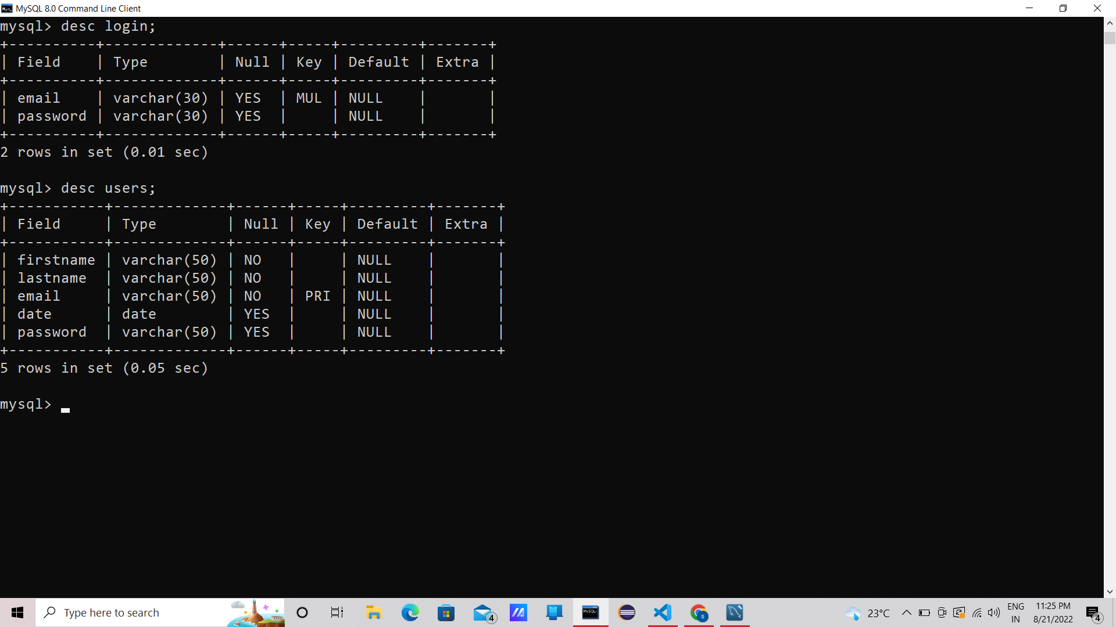

**3.7 User Interface Design**

# 

# 3.7.1 Registration Page

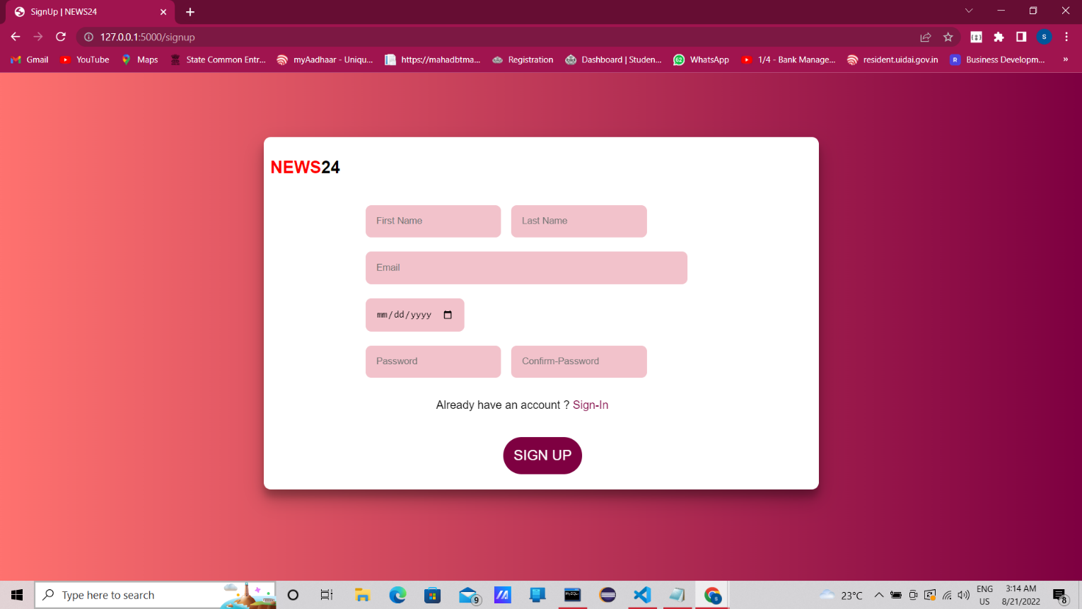

# 3.7.2 Sign-In Page

# 

# 3.7.3 Home Page

# 

**3.7.4 Categories**

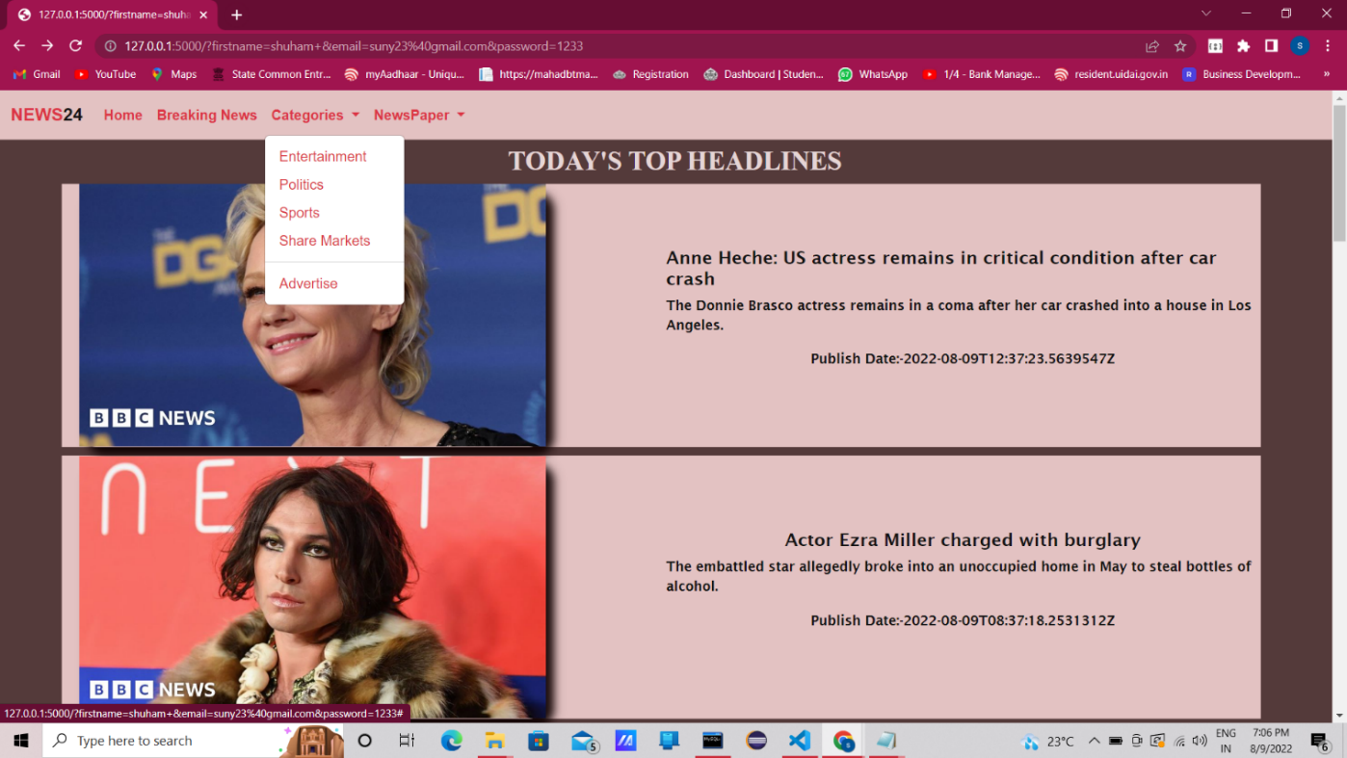

**3.7.5 Newspaper (Different Languages)** 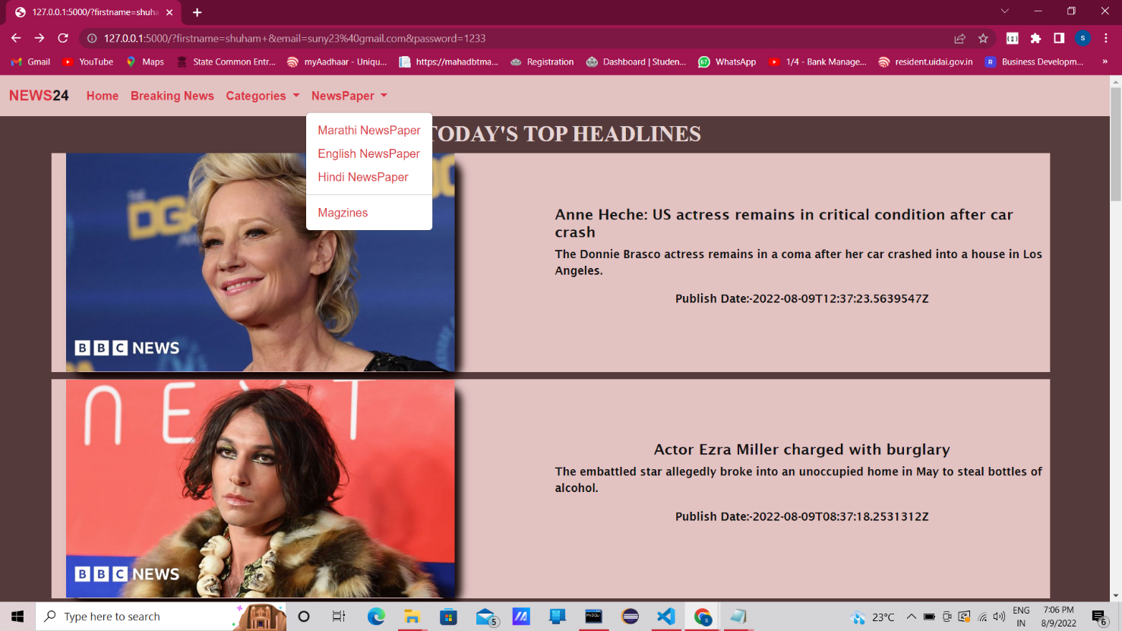

### 4. CODING

*from flask import Flask,render_template,request  
from newsapi import NewsApiClient  
  
app= Flask(__name__)  
  
@app.route("/")  
def home():  
    api_key = '25560f3cf53c433c9807c60595b373a6'  
     
    newsapi = NewsApiClient(api_key=api_key)  
  
    top_headlines = newsapi.get_top_headlines(sources = "bbc-news")  
    all_articles = newsapi.get_everything(sources = "bbc-news")  
  
    t_articles = top_headlines['articles']  
    a_articles = all_articles['articles']  
  
    news = []  
    desc = []  
    img = []  
    p_date = []  
    url = []  
  
    for i in range (len(t_articles)):  
        main_article = t_articles[i]  
  
        news.append(main_article['title'])  
        desc.append(main_article['description'])  
        img.append(main_article['urlToImage'])  
        p_date.append(main_article['publishedAt'])  
        url.append(main_article['url'])  
  
        contents = zip( news,desc,img,p_date,url)  
  
    news_all = []  
    desc_all = []  
    img_all = []  
    p_date_all = []    
    url_all = []  
  
    for j in range(len(a_articles)):  
        main_all_articles = a_articles[j]    
  
        news_all.append(main_all_articles['title'])  
        desc_all.append(main_all_articles['description'])  
        img_all.append(main_all_articles['urlToImage'])  
        p_date_all.append(main_all_articles['publishedAt'])  
        url_all.append(main_article['url'])  
         
        all = zip( news_all,desc_all,img_all,p_date_all,url_all)  
  
    return render_template('home.html',contents=contents,all = all)  
  
  
  
  
  
  
if __name__ == '__main__':  
    app.run(debug=True)*

### 5. USER MANUAL

* + - Open website.
    - Register, if already registered then login.
    - then, you get all the advantage of this website.

**6. CONCLUSION**

The explosion of readily available news and information on the web has, at least in part, eclipsed the long-held role of daily newspapers to deliver the news, but has yet to touch their unique contribution to the American democratic process: the ability to explore in depth highly complex subjects of public interest.

The results of the consultation suggest that moving the paper online is the best option given that it would reduce costs, be more environmentally-friendly and reach a larger audience. A change to a digital format is therefore recommended to maintain the benefits of the newspaper while addressing its current difficulties.

**7. BIBLIOGRAPHY :-**

**7.1 Bibliography & References : -**

[**www.W3School.com**](http://www.W3School.com)

[**www.javapoint.com**](http://www.javapoint.com)

[**www.Geeksforgeeks.com**](http://www.Geeksforgeeks.com)

**\*\*\*\*\* Thanking You \*\*\*\*\***